Robert Kristian Alm
Documentation

Starting over again 20/10/2016 – 21/10/2016

Windows server 2012 r2 doesn't like to going or reverse that much so after my decision to make the first AD of the assignment, (endor.local), as a physical AD, I had to install again the whole OS and as it is logical, (I was not prepared to make any over complicated migration of the server or something), now I have to start over again with everything.
This documentation describes 2 days:
1)Thursday 20/10/2016 which I installed and checked the additional hard disc.
2)Friday 21/10/2016 which I reinstalled Windows Server 2012 OS on Azazoth (Azazoth is the name that I gave to the computer that I use for the server)

Installing the Additional Hard disc to Azazoth 20/10/2012

The Thursday the 20th of October i had to install a second hard disc to Azazoth. The first time that i built Azazoth i thought that the second hard disc wasn't a necessity so I decided to deliver it back. As it seems my decision wasn't the right one and I had to install it again. At this point i have to point out that this hard disc is not the same that i delivered back the first time.
The best reason, (as I assume), for a second hard disc is because i will have two different AD so i will have to assign each one of them to different hard disc. Supposedly the existence of separate hard discs can give me few advantages on safety and speed, (i don't mean any raid topology), but nothing major, and probably it doesn't worth the fuzz to create backups for ADs of so small scale.
It is important to point out that i didn't the SMART test but so far i concern my hard disc works greatly so i don't see any reasons to do more tests on my hard disc.
Another thing that i wish to add is the fact that my new Hard disc it is assigned to the Letter B. I am not planning to use any diskette, and the letter D is usually taken for the dvd driver, and letter E for USB units.

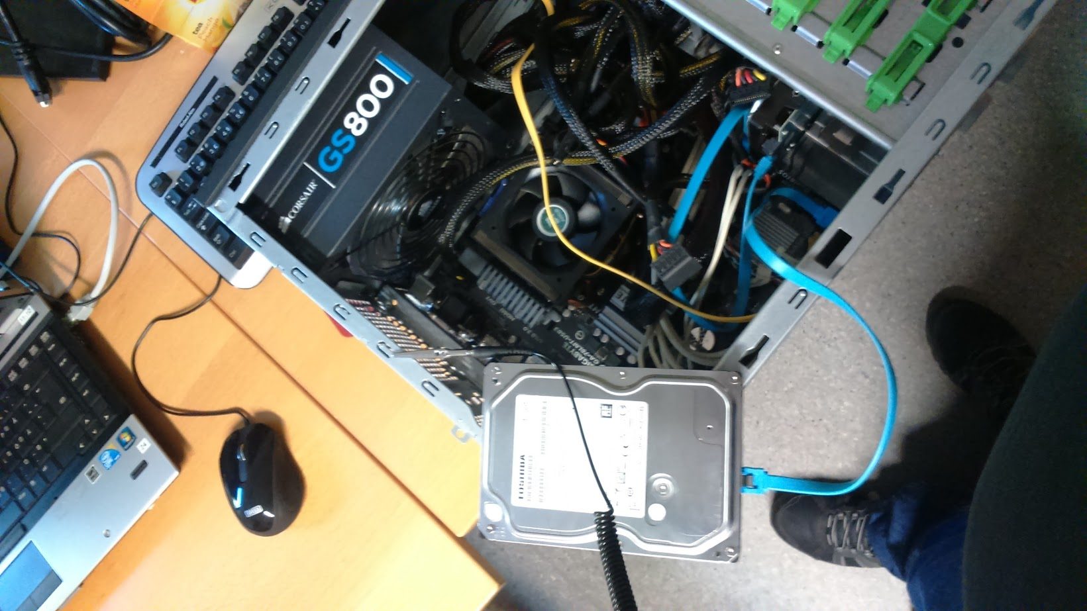

Installing again the Windows Server 2012 r2 OS 21/10/2012

Unfortunately, my decision to create the first AD of the assignment (Endor.local), was wrong and the problem with windows server 2012 R2 is that it doesn't go on reverse so i had to reinstall the windows server 2012 r2

I decided to use the disc0 (and my fist hard disc as well) to allocate the partition C and the disc one, (the new additional disc), to free letter B.

By the installation i faced one problem. It wasn't visible any boot menu so we fixed that by pressing f8 and f10 separately.

When i had the windows server 2012 r2 installed, my first action was to disable the IE advanced options, to disable the firewall for the private network to use the IE in order to install Opera, and to load the video tutorials that i am using.

I installed Hyper-V to Azazoth and I configured my ipv4 to the following adresses:

- ip 10.20.0.158
- subnet mask 255.255.255.0
- standard gateway 10.20.0.1
- DNS 127.0.0.1

I faced a small problem for 10 or 20 minutes because i forgot to install DNS role so i wasn't able to connect to internet.

As i said previously i installed Hyper-V and DNS roles to Azazoth. After Monday logically i will start with the AD endor.local. I have to check though if i changed the name of the computer to Azazoth as I intended to do.

